Aggregate extra tutorial feedback.

Well done for attempting this. Hopefully you will have been challenged to consider some interesting concepts associated with DW.

The questions:

* Total value of each brand by quarter. (sorry I missed out district on this soln)
* Compare sales of widgets year on year to see the effect of the BOGOF promotion in the first quarter.

1. Consider the issues and produce a schema for this aggregation
2. Write the necessary materialized views (or logic / pseudo code)
3. Write the necessary SQL for the creation of a dimension (or logic / pseudo code)

To support the bulleted queries the star needed is just:

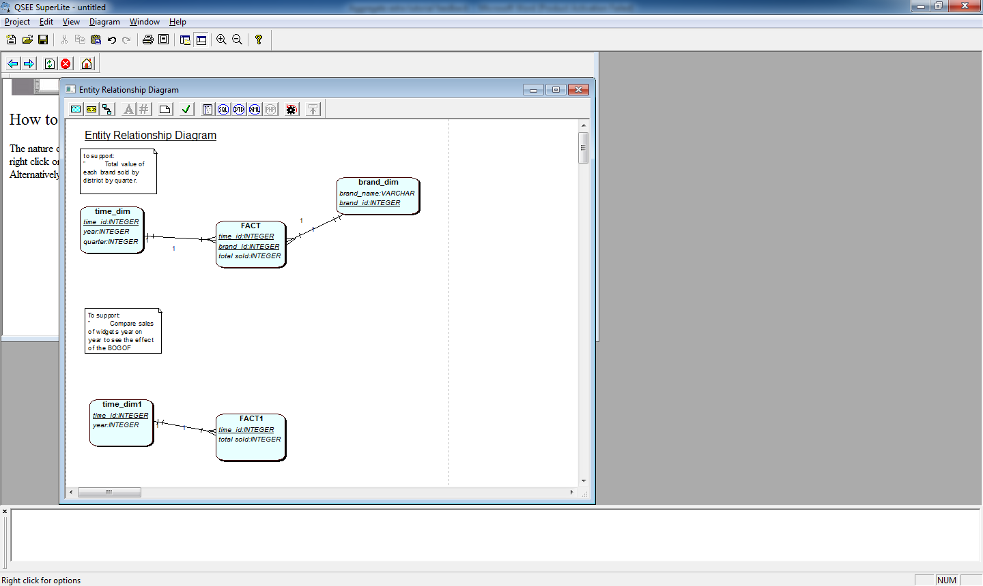

Some of the issues are – what is the PK for the FACT table. What level should the data be held at? If you keep the data at the lowest level (basically each sale) once you hold the data at a higher granularity (ie sales per year instead of sales per week (or day)) you lose many other potential reports.

You could combine the SS above. I kept them separate to help explain.

2.

CREATE view brand_quarter AS

SELECT product_key, product_desc, time_id, fical_perios, season, units_sold

FROM product_dim pd, sales_fact_table sf, time_dimension td

WHERE sf.product_key = pd.product_key ANF sf.time_id = td.time_id;

3.

CREATE table product_dim

AS SELECT product_id, product_desc FROM product;

(where the table product exists on the companies OLTP database system).